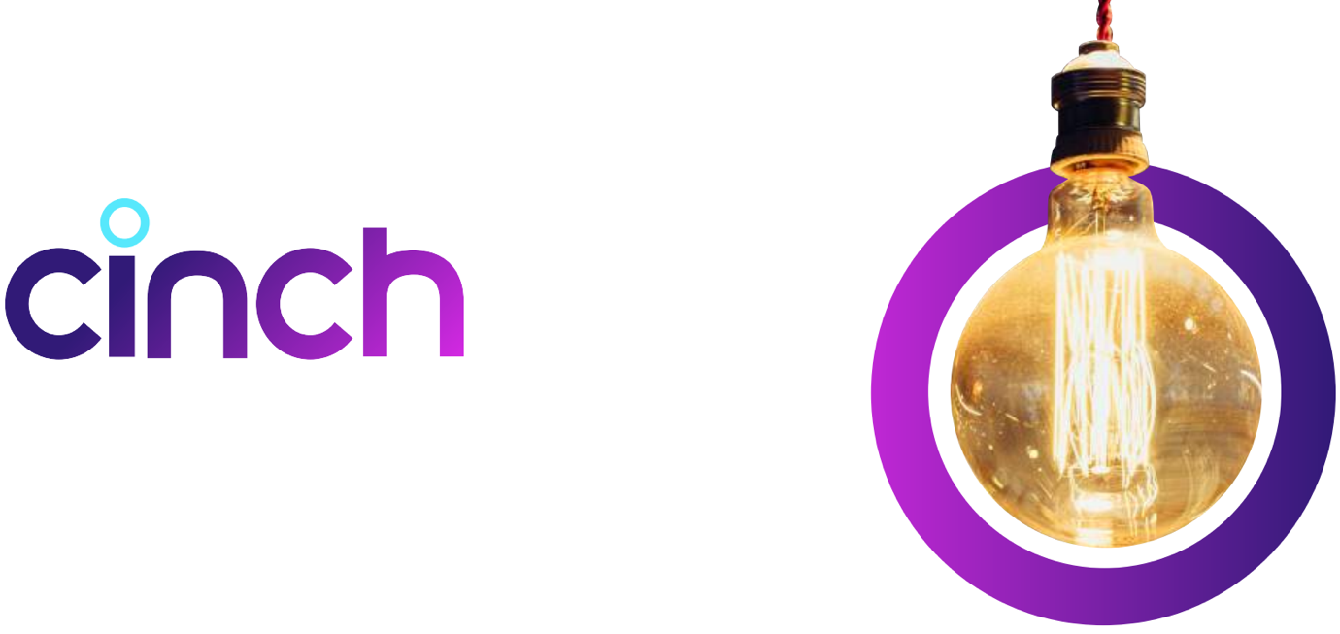

Head of Product
This role owns the entry point to our ecosystem, how customers find us, engage with us, and convert. Constellation Retail brings together cinch and Marshall Motor Group and we’re redefining how customers discover, choose and buy cars.
Search. Discovery. Personalisation. Journey orchestration. Conversion. If it impacts growth, engagement or funnel performance, it sits here.

The Role
We’re hiring a Head of Product to lead our Acquisition & Engagement tribe — responsible for turning demand into revenue through exceptional, data-led customer experiences.
This is a hands-on leadership role with real commercial accountability. You will own how customers find us, experience us, and convert, and turn that into growth.
What you’ll be working on

1. Conversion as a Product Discipline
- Own and optimise the end-to-end acquisition and engagement funnel
- Drive measurable improvements in conversion, activation, and revenue
- Treat conversion as a continuous system

2. The Customer Entry Point
- Redefine how customers search, discover and navigate our platform
- Lead the shift toward intuitive, low-friction, AI-powered experiences (including conversational interfaces)
- Build journeys that feel seamless, intelligent, intuitive and customer led

3. Data-Led Decision Making
- Establish a culture where every decision is backed by insight
- Define clear success metrics and ensure teams are accountable to them
- Use experimentation, behavioural data and customer insight to drive prioritisation

4. Strategy → Roadmap → Impact
- Own the vision and roadmap for Acquisition & Engagement
- Translate strategy into clear, focused delivery plans
- Balance short-term gains vs long-term capability building

5. Leadership & Execution
- Lead a tribe of 3-4 cross-functional squads (Product, Engineering, Design, Data)
- Set a high bar for ownership, pace and quality
- Develop Product Managers into strong, commercially-minded leaders

6. Stakeholder Influence & Trade-offs
- Work directly with senior stakeholders across Commercial, Marketing, Operations and Tech
- Make clear, confident prioritisation decisions with the ability to stand behind them
- Simplify complexity and align teams around what matters most

7. Product × Engineering × Design
- Partner deeply with Engineering with clear requirements and strong technical alignment
- Ensure Design is central to the product build and enhancements backed by research and data
- Operate as one team delivering outcomes

8. Build for Scale
- Make smart build vs buy decisions
- Ensure we’re creating scalable, reusable capabilities
- Leverage AI and data to unlock personalisation and efficiency at scale

What We’re Looking For
- Proven Head of Product / Lead Product experience in high-scale B2C or marketplace environments
- Hands on leader who has led product teams to deliver end-to-end user products and propositions
- Ability to handle a high-degree of complexity
- Proven ability to manage senior stakeholders with competing priorities, creating alignment by clearly linking product decisions and new capabilities to measurable business and P&L outcomes.
- Comfortable with ambiguity, turning it into a cohesive & exciting product strategy driving successful outcomes for our customers.
- Strong track record of driving conversion and growth through product
- Experience owning customer-facing journeys where UX directly impacts revenue
- You understand how product decisions translate into P&L impact
- You prioritise based on value
- You’re comfortable being accountable for real business outcomes
- You’re deeply data-led
- You know how to set up and run experimentation at scale
- You can turn insight into clear action
- Strong grasp of current tech stacks and architectures
- Comfortable in build-first environments, with clear judgement on when to buy
- Able to translate between product intent and engineering execution

You can lead and influence
- You bring clarity to complex environments with the ability to translate, inspire and lead
- You influence senior stakeholders without authority
- You drive accountability by building teams that own their outcomes and can tie results to business metrics and priorities

Why This Role?
- Own one of the most commercially critical areas of the business
- Direct impact on growth, revenue and customer experience
- Work across both a pure digital platform (cinch) and a physical + digital hybrid (Marshall)
- Build modern, AI-enabled customer journeys in an industry ready for disruption

